ARTIFICIAL INTELLIGENCE LAB
Lab 3: Uninformed Search Algorithms
BFS, DFS, DLS, IDDFS and UCS

Student Name: Abdul Raheem
Roll Number: 041
Subject: Artificial Intelligence Lab

Objective
To implement and compare uninformed search algorithms on a small graph, observe their visit/processing order, and compare path length with weighted path cost.

1. Introduction
Uninformed search algorithms explore a state-space graph without using a heuristic estimate. This lab implements Breadth First Search (BFS), Depth First Search (DFS), Depth Limited Search (DLS), Iterative Deepening Depth First Search (IDDFS), and Uniform Cost Search (UCS). The initial node is A and the goal node is G.

2. Graph and Assumptions
For Tasks 1 and 2, the original graph from the lab manual is used. Successor order is kept fixed: A has B and C; B has D and E; C has F; E has G. The root A is at depth 0. Search traces stop when the goal G is processed.
For Task 3, the original vertices and corridors are retained and the additional corridor C → G is added as specified by the manual's weighted extension. All weights are nonnegative.

3. Task 1 — BFS and DFS

3.1 Method
BFS uses a FIFO queue and explores nodes level by level. DFS uses a stack and explores one branch deeply before backtracking. Reversed successor insertion in the stack ensures the first listed neighbour is processed first.

3.2 Results
- BFS path: A → B → E → G
- BFS visit order: A, B, C, D, E, F, G
- DFS path: A → B → E → G
- DFS visit order: A, B, D, E, G
Interpretation: Both algorithms find the same goal path in this graph, but their visit orders differ. BFS explores the shallower nodes first, while DFS follows the B branch before returning to other branches.
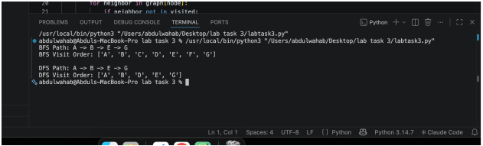

3.3 Source Code
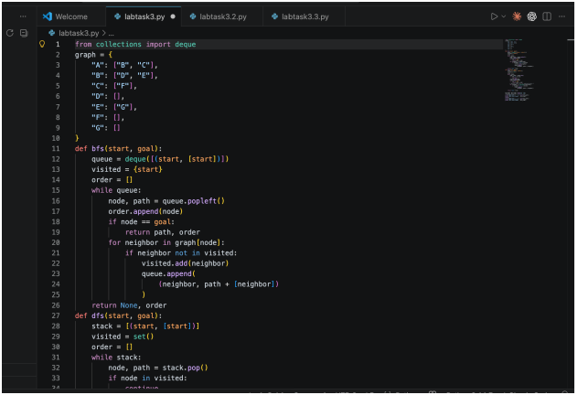

4. Task 2 — DLS and IDDFS

4.1 Method
DLS applies a depth bound to depth-first search. IDDFS repeats DLS using increasing depth limits, starting at depth 0. A path-local cycle check avoids revisiting a node already on the current path. FOUND means the goal was reached; CUTOFF means a depth bound prevented further exploration; FAILURE means the explored search had no remaining continuation.

4.2 Results
DLS limit 1: CUTOFF. DLS limit 2: CUTOFF. DLS limits 3 and 4: FOUND, path A → B → E → G.
IDDFS with maximum depth 1 and 2 does not find G. Maximum depths 3 and 4 find G at depth 3.
IDDFS repeats shallow searches, so some nodes are visited more than once across iterations.
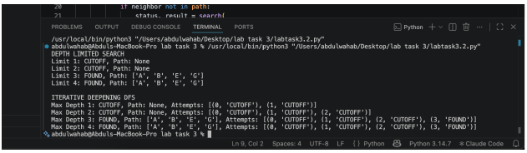

4.3 Source Code
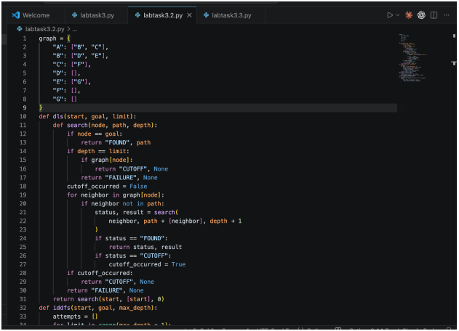

5. Task — Uniform Cost Search

5.1 Weighted Graph
Edge | Cost
A→B | 1
A→C | 2
B→D | 5
B→E | 1
C→F | 4
C→G | 10
E→G | 1
The added corridor C → G provides a two-edge route A → C → G. UCS chooses the path with the lowest accumulated cost, not necessarily the fewest edges.

5.2 Results and Cost Verification
UCS path: A → B → E → G. Total cost = 1 + 1 + 1 = 3.
BFS path on the same extended graph: A → C → G. Total cost = 2 + 10 = 12.
UCS processing order (node, accumulated cost): A(0), B(1), C(2), E(2), G(3).
Interpretation: BFS returns a route with fewer edges, but the route is expensive. UCS returns a three-edge route with a lower total cost. The cost of the returned UCS path is independently summed from its edge weights.
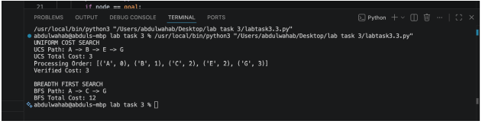

5.3 Source Code
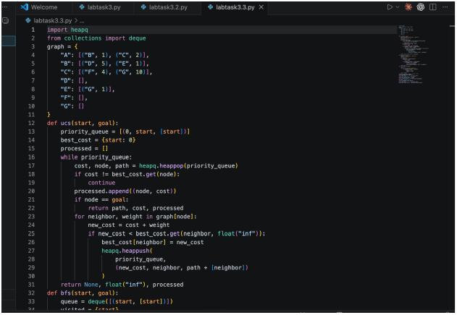

6. Edge-Case Testing
Start equals goal: calling a search with start A and goal A should return the path [A] immediately. Unreachable goal: a goal that does not appear in any reachable branch should result in no path (or a bounded-search status for DLS). Cycle handling: the supplied graph is acyclic, but DLS uses a path-local check so a cyclic extension will not recurse indefinitely along the same path. UCS assumes nonnegative edge costs.

7. Comparison
Algorithm | Main data structure | Complete? | Optimal?
BFS | Queue | Yes, finite branching | Yes for equal step costs
DFS | Stack | Not always | No
DLS | Depth bound / recursion | If limit sufficient | No
IDDFS | Repeated DLS | Yes under standard conditions | Yes for equal step costs
UCS | Priority queue | Yes with positive costs | Yes for nonnegative costs

8. Conclusion
This lab demonstrates that uninformed search strategies differ in their traversal order, memory needs, and path selection. BFS finds a shallow route, DFS explores deeply, DLS enforces a depth limit, IDDFS gradually increases that limit, and UCS optimizes accumulated path cost. In the weighted extension, BFS selects a route costing 12 while UCS finds a route costing 3.

9. Reflection
I learned that the shortest route by number of edges is not always the cheapest route. I also learned that depth limits can prevent a search from reaching a goal even when the goal exists, and that IDDFS repeats shallow work. In future work, I would add automated tests for start-equals-goal, unreachable goals, and cyclic graphs.

10. How to Run
Install Python 3 and run each file from the lab3 folder using the terminal:
python3 lab3_bfs_dfs.py
python3 lab3_depth_search.py
python3 lab3_ucs.py

